
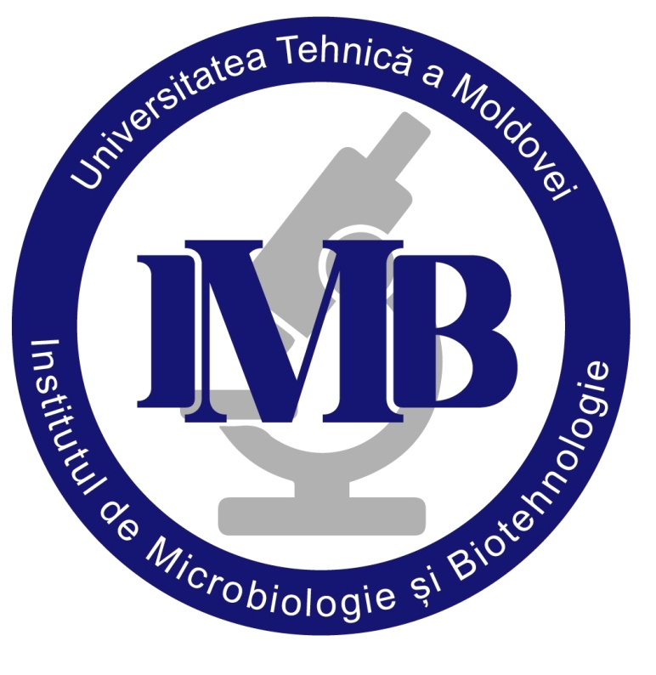
SYMPOSIUM “BIOTECHNOLOGIES AND SUSTAINABLE DEVELOPMENT”
Chișinău, Republic of Moldova,
May 12, 2026
Invitation: Symposium “Biotechnologies and Sustainable Development” – May 12, 2026
Dear Colleagues,
The Institute of Microbiology and Biotechnology of the Technical University of Moldova is pleased to invite you to participate in the National Scientific Symposium with International Participation entitled “Biotechnologies and Sustainable Development”, which will take place on 12 May 2026 in Chișinău (3/3 Academiei Street), Republic of Moldova, in a hybrid format (on-site and online).
The symposium aims to provide an interdisciplinary platform for researchers, academic staff, PhD students, and industry specialists to present and discuss recent advances in biotechnology contributing to sustainable development.
The scientific scope includes, but is not limited to: Bioeconomy and circular economy approaches; Environmental and microbial biotechnologies; Bioremediation and green technologies; Biotechnology and the One Health Approach; Smart and climate-resilient agriculture; Industrial biotechnology; Nanobiotechnology and innovative biomaterials; Social and economic dimensions of sustainable development.
The program will include: Plenary lectures (20 minutes); Invited lectures (15 minutes); Oral presentations (10 minutes); Poster session
Working language: English
Contributors may submit abstracts or full papers, which must be prepared in full compliance with the Author Guidelines and formatting templates provided in the attachment to this invitation. All submitted abstracts and full papers will be subject to peer review. Accepted contributions will be published in the official Symposium Proceedings, which will be assigned an ISBN, and each abstract/full paper will receive a Digital Object Identifier (DOI).
To register for the event, please access the following link: https://forms.gle/9WBPCNeaLHLfdMuz7
Authors are requested to submit their abstracts and full papers by email to the official Symposium address: symposiumIMB@gmail.com
IMPORTANT DEADLINES:
- Preliminary registration – March 12, 2026
- Abstracts/Full papers submission – March 25, 2026
- Peer review period – March 26 – April 30, 2026
- Notification of abstracts/full papers acceptance – May 1, 2026
- Final program – May 8, 2026

CONTACT DETAILS:
Institute of Microbiology and Biotechnology, Technical University of Moldova
3/3 Academiei Street, MD 2028, Chisinau, Republic of Moldova
Email: symposiumIMB@gmail.com
Contact person: Dr. Svetlana Codreanu
Tel: +373 795 56350

